


Software Requirement Specification

Smart Lens CCTV Surveillance System

Project Code | F22-49
Internal Supervisor | Faryal Shamsi
External Supervisor | ……
Project Team | Ali Raza Memon
Submission Date | 25-01-2025

Supervisor's Signature: _____________
Table of Contents
1.0 Introductin 1
1.1 Purpose of Document 1
1.2 Intended Audience 1
1.3 Document Convention 2
2.0 Overall System Description 3
2.1 Project Background 3
2.2 Project Scope 4
2.3 Not in Scope 4
2.4 Project Objectives 5
2.5 Stakeholders 6
2.6 Operating Environment 6
2.7 System Constraints 6
2.8 Assumptions & Dependencies 7
3.0 External Interface Requirements 8
3.1 Hardware Interfaces . 8
3.2 Software Interfaces 9
3.3 Communications Interfaces. 9
4.0 Functional Requirements 10
4.1 Functional Hierarchy 11
4.2 Functional Requirements for the System 12
4.3 Use Cases 13
5.0 Non-functional Requirements 15
NFR-1 Performance Requirements 16
NFR-2 Security Requirements 18
5.3 User Documentation 19
6.0 References 26
7.0 Appendices 27
Appendix A: Acronyms and Abbreviations 28
Appendix B: Glossary 28
Appendix C: Development Tools and Technologies 29

List of Tables
Table 1.0 Document Convention 04
Table 2.0 Registration 14
Table 3.0 Secure Login 15
Table 4.0 Add New Camera 16
Table 5.0 Remove Camera 17
Table 6.0 View live camera feed 18
Table 7.0 View Stored event clips 19
Table 8.0 Manage and Delete stored Event ciips 20
Table 9.0 Forward Alert 21
Table 10.0 Admin Update AI model 23

List of Figures
Figure 1.0 Functional hierarchy of Smart Lens AI Detection Model 9
Figure 2.0 Functional hierarchy of Smart Lens AI Detection App 10
Figure 3.0 Authentication Module Use Case 13
Figure 4.0 Camera Management Module Use Case 16
Figure 5.0 AI: Detection & Alert Generation Use Case 22

- Introduction

  - Purpose of Document
This Software Requirement Specification (SRS) document provides a detailed description of the "Smart Lens CCTV Surveillance System". Its purpose is to define the system's scope, functionalities, and constraints. It outlines the functional and non-functional requirements, external interfaces, and performance benchmarks that will guide the design, development, and testing of the project. This document serves as the foundational agreement between the development team, the supervisor, and project stakeholders.
  - Intended Audience

The developers of the project "Smart Lens " will make use of this document. This document will also be used by the supervisor and the evaluation committee to test and verify the system requirements.

Table 1. Document Convention
S. No. | Formatting Element | Style
1 | Font Style | Times new roman
2 | Font Size for Main Headings | 14, Bold
3 | Font Size for Subheadings | 12, Bold
4 | Font Size for Body Text | 12, Regular
5 | Line Spacing | 1.0

  - Abbreviations, and Acronyms
- AI: Artificial Intelligence
- API: Application Programming Interface
- CCTV: Closed-Circuit Television
- CNN: Convolutional Neural Network
- PSCA: Punjab Safe Cities Authority
- SSCA: Sindh Safe Cities Authority
- UI: User Interface

- Overall System Description

  - Project Background
Small and medium-scale shops are a vital part of developing economies like Pakistan but are highly vulnerable to security threats such as theft, looting, fire, and violence. Their current security relies on traditional, passive CCTV systems that are costly to maintain and ineffective for prompt prevention. These systems generate massive volumes of unfiltered footage, creating data overload and relying on error-prone human monitoring for review after an incident has occurred. While large-scale government projects (like PSCA) exist, they do not serve the specific, localized needs of small retailers. A significant gap exists for an affordable, intelligent, and proactive surveillance solution. "Smart Lens" aims to fill this gap by using AI to provide continuous threat detection and alerting.
  - Project Scope
The "Smart Lens" system is an AI-powered surveillance solution designed for small-scale businesses and local markets. The system integrates deep learning for continuous threat detection with a user-friendly mobile application.
The core functionalities within the scope of this project are:
- AI-Driven Continuous Threat Detection: The model will analyse live CCTV feeds to detect suspicious activities including theft, violence, looting, and fire hazards by recognizing complex behavioural patterns also can forward to local law enforcement.
- Motion-Based Video Recording: To reduce storage costs and data overload, the system will only save relevant footage that contains suspicious or anomalous events.
- Multi-Camera Integration: The mobile app will provide an interface for monitoring multiple cameras simultaneously.
- Camera Management: Users will be able to add new cameras and append metadata such as camera location (e.g., "Front Door," "Cash Register").
- Instant Mobile Notifications: A cross-platform mobile app will deliver instant alerts to shopkeepers, providing the event type, camera location, and the video clip of the suspicious event.
- Third-Party Sharing: The mobile app will provide an option for the shopkeeper to forward these alerts to third parties, such as friends, family, community groups.
  - Not in Scope
The following functionalities are explicitly not in the scope of this project:
- Facial Recognition and Biometric Tracking: The system will focus on behavioural patterns, not identifying specific individuals, to respect privacy concerns.
- Audio Surveillance: The system's analysis will be limited to video feeds only.
- Point-of-Sale (POS) Integration: The system will not integrate with cash registers or transaction data to detect employee theft (a feature noted in competitor Solink but not proposed for Smart Lens).
  - Project Objectives
The primary objectives of the Smart Lens project are:
- To automate the manual and inefficient process of monitoring CCTV footage.
- To provide smart detection of security threats (theft, fire, violence) to enable prompt intervention.
- To reduce data storage costs by implementing an intelligent, motion-based recording system that only saves motion based events.
- To empower shopkeepers by delivering instant, actionable alerts with video evidence via a user-friendly mobile app.
- To ensure safety of local businesses immediate alert will be send to local governance agencies upon user consent via message or email.
- To offer a scalable, affordable, and sustainable surveillance solution tailored to the specific needs and financial constraints of small businesses in developing regions.
  - Stakeholders

Our Stakeholders are:
- Users: Small business owners and shopkeepers in local markets.
- Secondary Users: Local security personnel and community watch groups.
- External Parties: Local law enforcement who may receive forwarded alerts.
- Development Team: Ali Raza Memon, Aadil Shah, Waseem Mazari.
- Project Supervisor: Ma’am Faryal Shamsi.
- Committee Members.
  - Operating Environment
The system will operate in the following environment:
- Hardware:
  - IP-based CCTV cameras.
  - High-Performance Server: A cloud-based server equipped with a dedicated Graphics Processing Unit (GPU) to perform continuous Deep Learning inference.
  - User smartphones to run the mobile application with stable internet connectivity
- Software:
  - AI Model: Python with OpenCV, and TensorFlow.
  - Backend Server: Node.js and Python Flask.
  - Mobile Application: Flutter.
  - Database: A NoSQL database for managing users, camera metadata, and alert logs.
  - System Constraints
The project is bound by the following constraints:
- Cost: The solution must be affordable for small-scale businesses, which limits hardware (server) and development choices.
- Data Privacy: The system must adhere to data protection regulations and avoid features that raise significant privacy issues.
- Accuracy: The system must be designed to minimize false positives, which can lead to "alert fatigue" and user mistrust.
- Environment: The AI model must be robust enough to handle challenging conditions in marketplaces, such as poor lighting, camera occlusions (blockages), and crowded scenes, environmental challenges.
- Connectivity: The system's continuous functionality is dependent on stable internet and electric power, which can be unreliable in the target deployment areas.
- User Expertise: The target users (shopkeepers) are assumed to have limited technical expertise, requiring the mobile app to be extremely user-friendly.
- Security: The system must be protected against hacking and data breaches to secure sensitive video feeds.
- Dataset: The AI model's accuracy is constrained by the quality and diversity of the publicly available datasets used for training.
- Hardware Dependency: The system relies on GPU acceleration to process video frames. The absence of a GPU will significantly degrade performance and increase latency (FR-6.2).
  - Assumptions & Dependencies
- Assumptions:
  - Shopkeepers have access to a stable internet connection for the cameras and server.
  - Shopkeepers own a smartphone with Android Operating system capable of running the mobile app.
  - The system will use standard IP cameras that can provide a accessible video stream (e.g., RTSP).
- Dependencies:
  - The project is dependent on publicly available datasets from Kaggle and other open sources for initial model training.
  - The project relies on open-source libraries and frameworks, including Python, OpenCV, TensorFlow, and Flutter.
  - The project is dependent on the availability of GUP for processing the camera feed.

- External Interface Requirements
A high-level context diagram would show the Smart Lens System at the center, interacting with IP Cameras (input), the Shopkeeper (via the mobile app), and Local Law Enforcement (as an external recipient of alerts).
  - Hardware Interfaces
- IP Cameras: The system must interface with IP-based CCTV cameras to capture the live video stream. This will be via the RTSP.
- Mobile Devices (Smartphones): The system will interface with the shopkeeper's Android device to display the mobile app UI, present alerts, and play video clips.
- Server & Processing Unit: The backend will use a GPU-enabled VM to process multiple camera streams in parallel.
  - Software Interfaces
- AI Models: The backend will interface with the trained AI models (e.g., TensorFlow files) to process video frames and receive detection results.
- Database: The backend server will interface with a database to store and retrieve user credentials, camera metadata, and alert logs.
- Mobile Operating Systems (Android): The mobile app (built in Flutter) will interface with the native capabilities of the phone's OS to receive push notifications and display the UI.
  - Communications Interfaces
- RTSP and HTTPs: The AI server will use this protocol to pull the live video stream from the IP cameras on the local network.
- HTTPS: All communication between the mobile app and the backend server (for login, managing cameras, fetching clips) will be secured using HTTPS.
- Push Notification Services (FCM): The backend server will use Firebase Cloud Messaging (FCM) for Android to send "instant alerts" to the mobile app.

- Functional Requirements
  - Functional Hierarchy

This section presents the basic parameters of Smart Surveillance detailing its basic functions and their subdivisions to present a logical ordering of the processes of the system.

Figure 1.0 Functional hierarchy of Smart Lens AI Detection Model

Description:
The following functional hierarchy figure illustrates the sequence of operations performed by the AI engine, starting from live video input to classification and alerting. It ensures motion-based filtering, efficient storage, and intelligent notification handling.

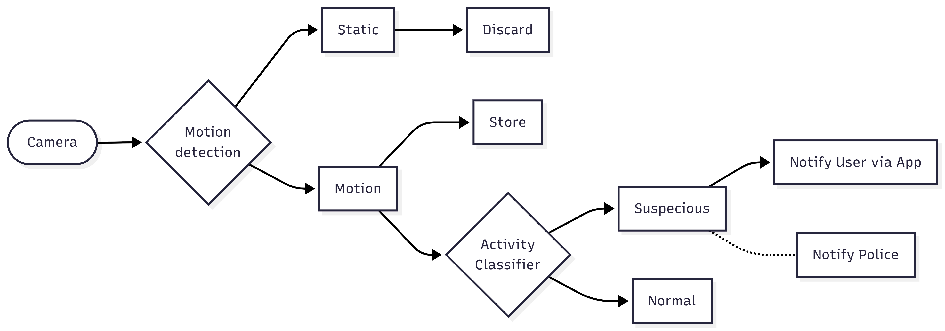

Figure 1.0 — Functional hierarchy of Smart Lens AI Detection Model

Figure 2.0 Functional hierarchy of Smart Lens AI Detection App
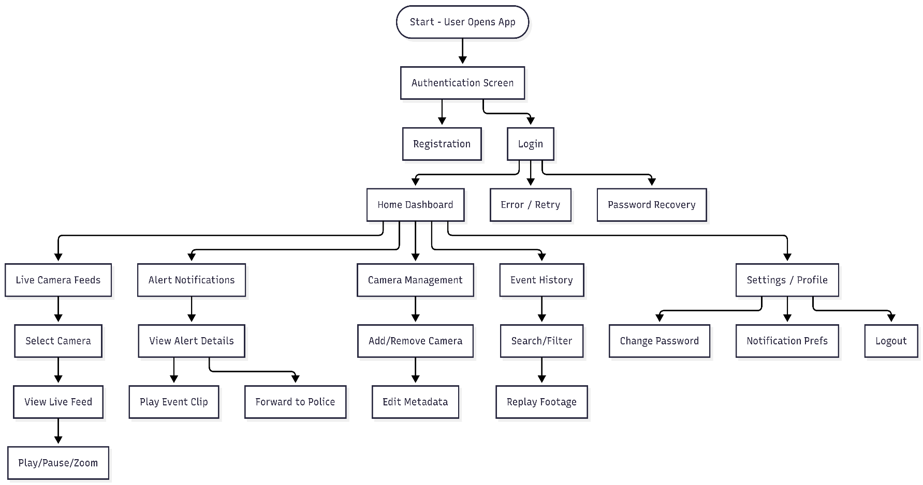
Description:
This figure represents the hierarchical navigation flow of the Smart Lens mobile application. It illustrates how the user interacts with the app, beginning from login and progressing through major functional modules such as live feed monitoring, alert handling, camera management, and event review.

Figure 2.0 — Functional hierarchy of Smart Lens Mobile App
- User Management
  - 1.1. User Authentication (Login and Logout)
- Camera Management
  - 2.1. Add New Camera
  - 2.2. Edit Camera Metadata (e.g., Location Name)
  - 2.3. Remove Camera
- Surveillance & Monitoring
  - 3.1. View Multi-Camera Live Feed
  - 3.2. AI-Powered Threat Detection
    - 3.2.1. Detect Theft
    - 3.2.2. Detect Violence
    - 3.2.3. Detect Fire Hazards

- Alerting & Response
  - 4.1. Receive Instant Mobile Alert and Local law enforcement alert
  - 4.2. View Suspicious Video Clip
  - 4.3. Forward Alert to Third Party
- Storage Management
  - 5.1. Motion-Based Event Recording

4.2 Functional Requirements for the System

FR-1: User Management
FR-1.1: The system shall allow users to register an account using valid credentials such as email, phone number, and password.
FR-1.2: The system shall provide a secure login mechanism using authentication protocols.
FR-1.3: The system shall allow users to reset or recover their password through email verification.
FR-1.4: The system shall allow users to edit and update their profile information such as shop name, contact details, and camera location tags.
FR-1.5: The system shall allow users to delete their account from the system securely.
FR-1.6: The system shall allow users to manage their preferences for notifications and alert settings.
FR-1.7: The system shall support Two-Factor Authentication (2FA) to enhance account security. During registration, login, and password recovery, the system shall require a one-time verification code sent to the user’s registered email, with each code expiring within 5 minutes.
FR-1.8: The system shall manage secure user sessions using JWT, including session creation, expiration, and invalidation on logout and credential changes.

FR-2: Camera Management
FR-2.1: The system shall allow users to add new IP cameras by providing the camera’s RTSP link and location label (e.g., ‘Entrance,’ ‘Cash Counter’).
FR-2.2: The system shall allow users to edit the camera details such as camera name, location.
FR-2.3: The system shall allow users to remove existing cameras from their account.
FR-2.4: The system shall validate the connectivity of newly added cameras before saving them.
FR-2.5: The system shall store metadata of each camera (e.g., Camera ID, Location, Stream URL) in the database.

FR-3: Continuous Surveillance and Monitoring
FR-3.1: The system shall provide a dashboard for users to view live feeds from multiple cameras simultaneously.
FR-3.2: The system shall continuously analyse live video streams using the AI model for suspicious activities.
FR-3.3: The system shall detect and classify specific events such as:
- FR-3.3.1: Theft any suspicious movement near sensitive zones.
- FR-3.3.2: Violent activities and crowd disturbances.
- FR-3.3.3: Fire and smoke hazards.
- FR-3.3.4: The system shall overlay bounding boxes or indicators on the detected objects, events in the video feed.
- FR-3.3.5: The system shall automatically record only those video clips that contain motion events.

FR-4: Alert and Notification System
FR-4.1: The system shall send instant mobile alerts to the user when a suspicious activity is detected.
FR-4.2: Each alert shall include details such as event type (e.g., fire, theft), camera location, and time of detection.
FR-4.3: The system shall attach a short video clip of the detected event in the notification.
FR-4.4: The system shall allow users to forward an alert to external parties such as a community group.

FR-5: Event Recording and Storage Management
FR-5.1: The system shall record and save only motion-based to optimize storage.
FR-5.2: The system shall store video clips with metadata such as event type, camera ID, and timestamp.
FR-5.3: The system shall allow users to view, download, and delete stored video clips from the mobile app.
FR-5.4: The system shall maintain a log of all events detected for audit and review purposes.
FR-5.5: The system shall automatically manage storage by deleting older clips when the defined storage limit is reached.

FR-6: AI Engine and Processing
FR-6.1: The system shall use a trained AI model to analyse live CCTV footage.
FR-6.2: The AI model shall process video frames for detection.
FR-6.3: The system shall allow retraining and updating the AI model using new datasets.
FR-6.4: The AI engine shall output detection results with confidence scores for each event type.
FR-6.5: The system shall minimize false positives by applying confidence thresholds.

FR-7: Security and Privacy
FR-7.1: The system shall encrypt user credentials in storage and during transmission.
FR-7.2: The system shall restrict access to live video feeds and stored clips to authorized users only.
FR-7.3: The system shall log all user activities for audit purposes (e.g., login attempts, data deletion).
FR-7.4: The system shall implement secure communication using HTTPS for all client-server interactions.
FR-7.5: The system shall ensure that video feeds are not shared publicly or to unauthorized third parties except where explicitly initiated by the authenticated user via FR-4.4.

FR-8: System Administration
FR-8.1: The system shall provide an administrator interface for managing users, cameras, and event logs.
FR-8.2: The administrator shall be able to monitor live system status and AI performance metrics.
FR-8.3: The administrator shall be able to remove or block users violating the system’s terms of use.
FR-8.4: The administrator shall have access to reports summarizing system activity and detections.

FR-9: Search and Filtering
FR-9.1: The system shall allow users to search for recorded events by date, event type, or camera location.
FR-9.2: The system shall enable filtering of alerts and videos based on event severity (e.g., “Fire Only”).
FR-9.3: The system shall provide sorting options (latest first, by camera, etc.) for easy navigation.

FR-10: System Performance
FR-10.1: The system shall ensure instant alert generation of event detection.
FR-10.2: The system shall maintain video quality available while performing continuous analysis.
FR-10.3: The system shall support simultaneous streaming from multiple cameras without lag.
FR-10.4: The system shall ensure 95% uptime under stable internet conditions.

4.3. Use Cases
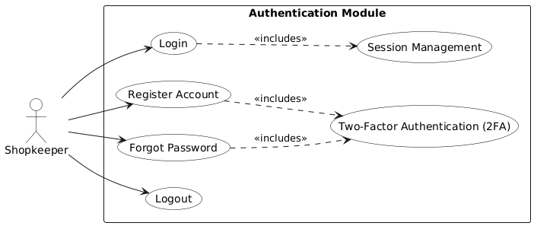
Use Case Diagram: Provides the basis for these use cases, showing actors: Shopkeeper, Camera, AI Model, Mobile App, and Police and their actions.
Figure 3.0 — Authentication Module Use-Case Diagram

Use Case 1: User Registration
Use case Id: | UC-UM-001
Actors: | Shopkeeper
Feature: | User Management (FR-1.1)
Pre-condition: | Shopkeeper does not have an existing account and has access to the mobile app.
Scenarios
Step# | Action | Software Reaction
1. | Shopkeeper selects the "Register" option. | System displays the registration form requesting email, phone number, and password.
2. | Shopkeeper fills in the required details and submits. | System validates the credentials (e.g., unique email, strong password format).
3. | Validation is successful. | System encrypts the password (FR-7.1) and saves the new user account to the database (FR-1.1).
4. |  | System automatically redirects the Shopkeeper to the login screen.
Alternate Scenarios:
1a: | The email address entered is already registered. | System displays an error: "Account already exists. Please log in or reset password."
1b: | Password format is too weak. | System displays specific requirements (e.g., "Password must contain one capital letter") and prompts for correction.
Post Conditions
Step# | Description
1. | A new shopkeeper account is securely created and registered.
2. | The user is redirected to the login screen to start their first session.
Use Case Cross referenced: |  | UC-UM-002 (User Login)

Use Case 2: Secure User Login
Use case Id: | UC-UM-002
Actors: | System Administrator
Feature: | System Administration (FR-8.2)
Pre-condition: | Administrator is logged into the dedicated Admin Interface.
Scenarios
Step# | Action | Software Reaction
1. | Shopkeeper enters credentials (email/phone and password). | System validates the format of the entered credentials.
2. | Shopkeeper clicks the "Login" button. | System verifies credentials against the database and, if valid, generates a JWT token (FR-1.2, FR-7.4).
3. | Login is successful. | System sends the JWT token to the mobile app and redirects the Shopkeeper to the Multi-Camera Dashboard.
Alternate Scenarios:
1a: | Credentials are invalid or token has expired. | System displays a generic error message: "Invalid email or password" and logs the failed attempt (FR-7.3).
1b: | Shopkeeper clicks "Forgot Password." | System initiates the password recovery process (Cross-Reference to UC-UM-003).
Post Conditions
Step# | Description
1. | Shopkeeper is securely logged into the system, and a valid JWT is issued for session management.
Use Case Cross referenced: |  | FR-6.5 (Minimize False Positives), FR-7.3 (Log Activities)

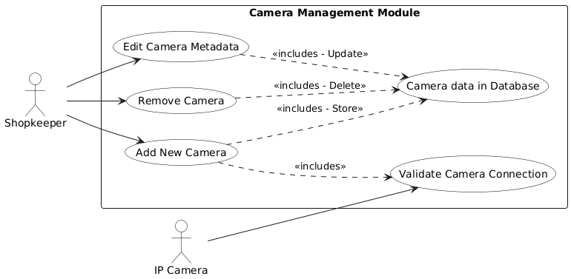
Figure 4.0 — Camera Management Module Use-Case Diagram

Use Case 3: Add New Camera
Use case Id: | UC-CM-001
Actors: | Shopkeeper
Feature: | Camera Management (FR-2)
Pre-condition: | Shopkeeper is logged in. The new IP camera is ready on the local network with a valid RTSP stream URL.
Scenarios
Step# | Action | Software Reaction
1. | Shopkeeper selects the "Add Camera" option. | System displays a form for entering the RTSP URL, Camera Name, and Location Label (FR-2.1).
2. | Shopkeeper enters all required details and taps "Save." | The Backend Server receives the details and initiates FR-2.4 validation.
3. |  | The Backend Server attempts to connect to the RTSP stream and verifies its accessibility.
4. | Validation is successful. | System stores the camera metadata (FR-2.5) and confirms registration.
Alternate Scenarios:
1a: | The entered RTSP URL is invalid or the connection attempt fails (FR-2.4). | System displays an error message: "Connection failed. Check stream URL or network settings."
1b: | Shopkeeper leaves required fields empty. | System highlights missing fields and prompts the user to complete them.
Post Conditions
Step# | Description
1. | The new camera is registered and begins streaming to the AI Engine for analysis.
2. | The camera's metadata is stored in the database.
Use Case Cross referenced: |  | UC-MM-001: View Live Feed

Use Case 4: Remove Registered Camera
Use case Id: | UC-CM-002
Actors: | Shopkeeper
Feature: | Camera Management (FR-2.3)
Pre-condition: | Shopkeeper is logged in and has registered cameras.
Scenarios
Step# | Action |  | Software Reaction
1. | Shopkeeper navigates to the Camera Management screen. |  | System displays a list of all registered cameras.
2. | Shopkeeper selects the "Remove" option next to a specific camera. |  | System displays a confirmation prompt: "Are you sure you want to remove this camera?"
3. | Shopkeeper confirms the removal. |  | System deletes the camera's metadata from the database (FR-2.3).
4. |  |  | The Backend Server terminates the AI analysis stream for that camera.
Alternate Scenarios:
1a: | Shopkeeper attempts to remove the last remaining camera. |  | System displays a warning that no cameras will be monitored, but proceeds with removal if confirmed.
1b: | The database operation to delete the record fails. |  | System displays an error message and prompts the Shopkeeper to try again.
Post Conditions
Step# | Description
1. | The selected camera is completely deregistered and removed from the dashboard and analysis stream.
2. | The AI Engine stops consuming resources for the removed camera stream.
Use Case Cross referenced: |  | UC-CM-001 (Add New Camera)

Use Case 5: View Multi-Camera Live Feed
Use case Id: | UC-MM-001
Actors: | Shopkeeper, IP Cameras
Feature: | Surveillance & Monitoring (FR-3.1, FR-10.3)
Pre-condition: | Shopkeeper is logged in. At least one camera is registered and online.
Scenarios
Step# | Action | Software Reaction
1. | Shopkeeper opens the Mobile App to the main Dashboard. | The Mobile App requests active camera streams from the Backend Server.
2. |  | The Backend Server pushes the live video data to the Mobile App.
3. |  | The Mobile App simultaneously displays the video streams from all active cameras (FR-10.3) in a grid format.
4. | Shopkeeper observes the streams. | The system maintains minimum best quality (FR-10.2) and smooth frame rates.
Alternate Scenarios:
1a: | A camera stream connection is lost mid-session. | The system displays a "Stream Disconnected" placeholder in that specific camera's panel.
1b: | Shopkeeper's network bandwidth drops severely. | The system may temporarily reduce the stream quality to minimize lag.
Post Conditions
Step# | Description
1. | The Shopkeeper is continuously viewing the live feed from active cameras without lag.
Use Case Cross referenced: |  | UC-AR-001: Receive Alert

Use Case 6: View Stored Event Clips
Use case Id: | UC-SM-002
Actors: | Shopkeeper
Feature: | Storage Management (FR-5.3), Search and Filtering (FR-9)
Pre-condition: | Shopkeeper is logged in. At least one suspicious event clip has been recorded and stored.
Scenarios
Step# | Action | Software Reaction
1. | AI Engine processes a video frame using the trained CNN model (FR-6.1, FR-6.2). | AI Model calculates a Confidence Score (FR-6.4) for potential suspicious events (Theft, Fire, Violence).
2. | Confidence Score exceeds the predefined threshold (FR-6.5). | AI Engine classifies the event (e.g., "Violence") and triggers the alert and recording sequence.
Alternate Scenarios:
1a: | Confidence Score is below the threshold, indicating a low-confidence detection. | System logs the score for review but discards the frame, minimizing false positives (FR-6.5).
1b: | The AI model encounters corrupted frames or unexpected data. | System skips the corrupted frame and continues processing the next frame, logging the error.
Post Conditions
Step# | Description
1. | A suspicious event is classified, and the system proceeds to record and alert the Shopkeeper.
Use Case Cross referenced: |  | UC-AR-001: Receive Alert

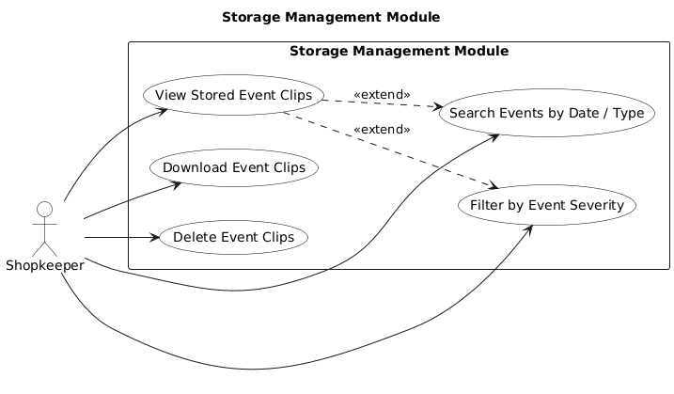

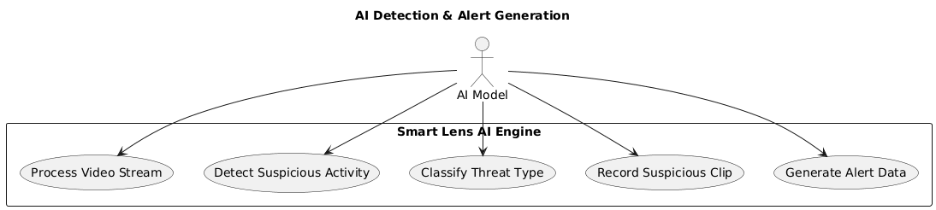
Figure 3.0 — AI Detection Module Use- Case diagram
Use case Id: | UC-SM-003
Actors: | Shopkeeper
Feature: | Storage Management (FR-5.3)
Pre-condition: | Shopkeeper is viewing the list of recorded event clips (UC-SM-002).
Scenarios
Step# | Action |  | Software Reaction
1. | Shopkeeper selects one or more event clips from the log (UC-SM-002). |  | System displays options: "View," "Download," "Delete."
2. | Shopkeeper taps "Delete." |  | System displays a confirmation prompt: "Are you sure you want to permanently delete these clips?"
3. | Shopkeeper confirms the deletion. |  | System removes the video file from the storage server and deletes its corresponding metadata record (FR-5.3).
4. |  |  | System refreshes the list, confirming the clip(s) have been deleted.
Alternate Scenarios:
1a: | Deletion fails due to a server connection error. |  | System displays an error message: "Deletion failed. Please try again."
1b: | Shopkeeper attempts to delete a clip but cancels at the confirmation prompt. |  | System retains the clip and returns to the alert log without any change.
Post Conditions
Step# | Description
1. | The selected event clip(s) and their metadata are permanently removed from the system.
Use Case Cross referenced: |  | UC-SM-002 (View Stored Event Clips)

Use Case 8: Forward Alert
Use case Id: | UC-AR-001
Actors: | Shopkeeper, Local Law Enforcement/Third Party
Feature: | Alerting & Response (FR-4.5)
Pre-condition: | Shopkeeper is viewing an alert and has a designated third-party contact configured.
Scenarios
Step# | Action | Software Reaction
1. | Shopkeeper taps the "Share Alert" button on the alert detail screen. | The Mobile App displays a confirmation prompt.
2. | Shopkeeper confirms the action and selects the recipient (e.g., Friend or Public). | The Backend Server securely prepares a link to the recorded video clip.
3. |  | The Backend Server sends the secure link/details via the selected communication channel (e.g., SMS, email).
4. |  | System logs the sharing action (FR-7.3) and shows confirmation to the Shopkeeper.
Alternate Scenarios:
1a: | Transmission to the external party fails due to network error. | System displays an error and prompts the Shopkeeper to try an alternate sharing method.
Post Conditions
Step# | Description
1. | The alert details and video evidence are securely transmitted to the chosen third party.
Use Case Cross referenced: | UC-AR-002: Receive Alert

Use Case 9: Receive Suspicious Activity Alert
Use case Id: | UC-AR-002
Actors: | AI Model (Initiator), Mobile App, Shopkeeper, Third party ( police or local law enforcement )
Feature: | Alerting & Response (FR-4.1)
Pre-condition: | Shopkeeper is logged into the mobile app and push notifications are enabled. AI Model is actively analyzing the camera feed.
Scenarios
Step# | Action |  | Software Reaction
1. | AI Model analyzes feed and detects a "Suspicious Activity" (e.g., theft, fire) with high confidence. |  | AI Model triggers a detection event, including event type and timestamp (FR-6.5, FR-3.3).
2. |  |  | The Smart Storage Manager records the relevant video clip (FR-5.1) and stores metadata (FR-5.2).
3. |  |  | The Backend Server sends an "Alert + Clip Link" to FCM/APNS (FR-4.1) immediately
4. |  |  | Shopkeeper and local law enforcement (police) receives the alert (FR-4.2),
5. | Shopkeeper taps the notification and opens the app. |  | The Mobile App fetches the clip and displays the alert details (FR-4.3).
Alternate Scenarios:
1a: | Shopkeeper is logged in but has notifications disabled (FR-1.6). |  | System logs the event (FR-5.4) but does not push the notification. The alert is only visible in the in-app log.
1b: | No suspicious activity is detected. |  | The system continues surveillance (FR-3.2) without generating events.
Post Conditions
Step# | Description
1. | Shopkeeper is instantly notified of the threat.
2. | The suspicious video clip and metadata are stored and available for review (FR-5.4).
Use Case Cross referenced: |  | UC-AR-002: Forward Alert, UC-SM-002: View Stored Clips

Use Case 10: Admin Update AI Model (FR-6.3)
Use case Id: | UC-SA-001
Actors: | System Administrator
Feature: | AI Engine and Processing (FR-6.3)
Pre-condition: | Administrator is logged into the Admin Interface. A new, retrained AI model file is available.
Scenarios
Step# | Action |  | Software Reaction
1. | Administrator accesses the AI Management module |  | System displays the current model version and performance metrics.
2. | Administrator uploads the new AI model file and initiates the update process. |  | System validates the file format and initiates the model swap/deployment process (FR-6.3).
3. | Model deployment is complete and stable. |  | System confirms the new model is loaded and is actively analyzing live streams.
4. |  |  | System begins logging the performance of the new model (FR-8.2).
Alternate Scenarios:
1a: | The new model fails validation or deployment. |  | System automatically reverts to the previous stable AI model version and notifies the Administrator.
1b: | The Administrator cancels the update during the upload phase. |  | System deletes the uploaded file and retains the current model version.
Post Conditions
Step# | Description
1. | The AI analysis for all active cameras is running on the latest, updated model version.
2. | The system has logged the details of the model update for audit purposes.
Use Case Cross referenced: |  | UC-SM-001 (AI-Powered Threat Detection)

5.0 Non-functional Requirements

NFR-1 Performance Requirements
NFR-1.1: The system shall generate and send a push notification to the user's mobile device in under 30 seconds from the moment a suspicious event is detected by the AI engine (Ref: 5.1).
NFR-1.2: The mobile application shall load a selected live video stream in under 5 seconds on a stable internet connection (Ref: 5.1).
NFR-1.3: The AI engine shall support continuous analysis from a minimum of 4 cameras without significant performance lag (Ref: FR-10.3).
NFR-1.4: The system shall maintain a minimum video processing and recording quality of 720p to ensure clear visual evidence (Ref: FR-10.2).
NFR-1.5: The cloud components of the system shall maintain 99% uptime under normal operating and internet conditions (Ref: FR-10.4).

NFR-2 Security Requirements
NFR-2.1: The system shall provide a secure user authentication mechanism (e.g., JWT, OAuth) for both the mobile app and administrative access (Ref: FR-1.2).
NFR-2.2: All data transmission between the mobile app and the backend server, as well as between cameras/edge devices and the backend, shall be encrypted using HTTPS/SSL (Ref: FR-7.4).
NFR-2.3: All sensitive user data (passwords) and stored video clips shall be encrypted at rest using industry-standard algorithms (e.g., AES-256) (Ref: FR-7.1).
NFR-2.4: The system shall enforce role-based access control. A "Shopkeeper" (User) shall only have access to their own cameras and data, while an "Administrator" role shall have system-wide management privileges (Ref: FR-8.1).
NFR-2.5: The system shall log all critical user activities and security events (e.g., login attempts, camera deletion) for audit purposes (Ref: FR-7.3).

NFR-3 Privacy Requirements
NFR-3.1: The system shall be designed to focus on behavioral patterns and shall not include facial recognition or biometric tracking features (Ref: 2.3).
NFR-3.2: Video footage shall be treated as private and confidential. The system shall ensure that video feeds are not shared publicly or with any unauthorized third parties (Ref: FR-7.5).
NFR-3.3: The system shall adhere to local data protection and privacy regulations.

NFR-4 Accuracy and Reliability Requirements
NFR-4.1: The system shall be designed to "minimize false positives" to prevent "alert fatigue" for the shopkeeper (Ref: 2.7, 5.1).
NFR-4.2: The AI engine shall apply configurable confidence thresholds to ensure only events with a high probability of being a real threat trigger an alert (Ref: FR-6.5).
NFR-4.3: The system must be reliable and shall treat safety-critical events (like "fire hazards") as high-priority, ensuring they are not missed due to system error (Ref: 5.2).
NFR-4.4: The AI model must be robust enough to perform reasonably under challenging environmental conditions, such as variable lighting and partial occlusions (Ref: 2.7).
NFR-4.5: The AI engine shall be designed for 24/7 continuous operation (Ref: 5.1).

NFR-5 Usability Requirements
NFR-5.1: The mobile application interface shall be simple, intuitive, and user-friendly, designed for target users (shopkeepers) who may have limited technical expertise (Ref: 2.7).
NFR-5.2: All alert notifications shall be clear, concise, and immediately actionable, providing the event type and camera location (Ref: FR-4.2).

NFR-6 Maintainability Requirements
NFR-6.1: The system architecture shall allow the AI model to be retrained and updated with new datasets to improve detection accuracy and adapt to new threats over time (Ref: FR-6.3).
NFR-6.2: The system shall provide an administrator dashboard for monitoring system health and AI performance metrics (Ref: FR-8.2).

NFR-7 Documentation Requirements
NFR-7.1: The project shall deliver a clear and simple User Manual, video guide (for shopkeepers) detailing system setup, app usage, and troubleshooting.
NFR-7.2: The project shall provide comprehensive Technical Documentation for developers and administrators, detailing the system architecture, API, and deployment procedures.

6. References
[1] Mermid.com
[2] PlantUML.com

7.0 Appendices

Appendix A: Acronyms and Abbreviations
- AI: Artificial Intelligence
- API: Application Programming Interface
- APNS: Apple Push Notification Service
- CCTV: Closed-Circuit Television
- CNN: Convolutional Neural Network
- FCM: Firebase Cloud Messaging
- FR: Functional Requirement
- HTTPS: Hypertext Transfer Protocol Secure
- NFR: Non-functional Requirement
- PSCA: Punjab Safe Cities Authority
- RTSP: Real-Time Streaming Protocol
- SRS: Software Requirement Specification
- SSCA: Sindh Safe Cities Authority
- UI: User Interface

Appendix B: Glossary
- Smart Lens: The official name of the AI-powered surveillance system being developed.
- Threat Detection: The core process of the AI engine analyzing video to identify suspicious activities like theft, fire, or violence.
- Motion-Based Recording: The system's storage-saving feature, where video is only recorded when a suspicious event is detected, rather than 24/7.
- AI Engine: The software component responsible for running the AI models to analyze video feeds.
- Alert Fatigue: A state of user mistrust or desensitization caused by receiving too many false positive alerts from the system.
- Occlusion: An environmental challenge where an object or person in the video feed is partially or fully blocked from the camera's view.

Appendix C: Development Tools and Technologies
- Programming Language (AI Engine): Python
- AI Frameworks: TensorFlow or PyTorch
- Video Processing Library: OpenCV
- Backend Server: Node.js or Python Flask
- Mobile Application: Flutter or React Native
- Database: Relational (e.g., PostgreSQL) or NoSQL (e.g., MongoDB)
- Version Control: Git and GitHub

